B.Dega Simha Reddy

192111123

CSA4053-MIS

3.CONNECTIVITY PROGRAM FOR PAYROLL SYSTEM

FORM:-

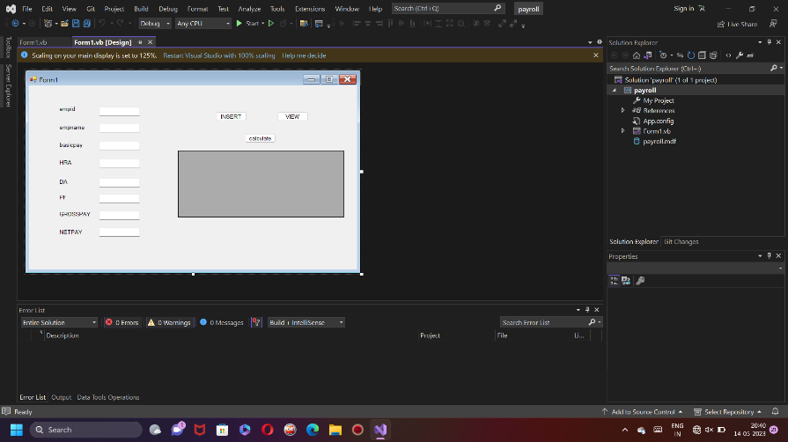

DATABASE:-

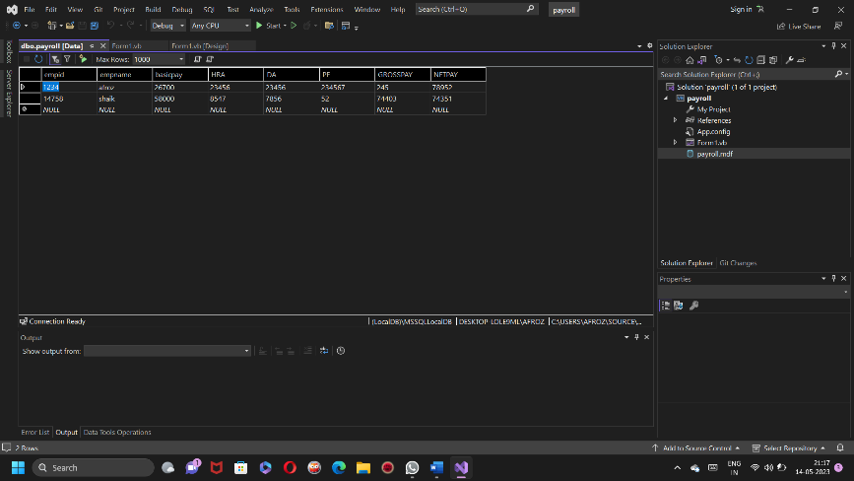

CODE:-

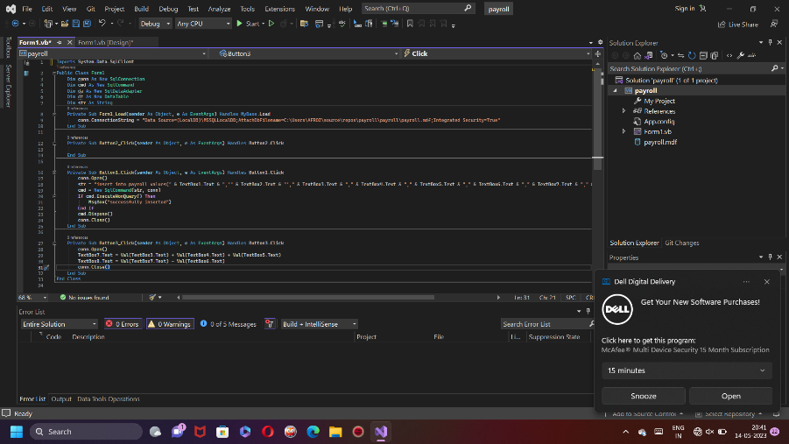

OUTPUT:-

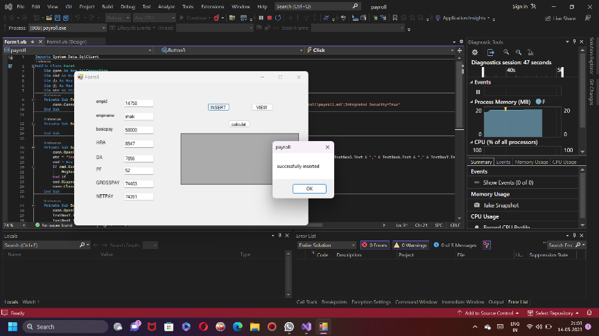

4.CONNECTIVITY PROGRAM FOR STUDENT MARKSHEET

FORM:-

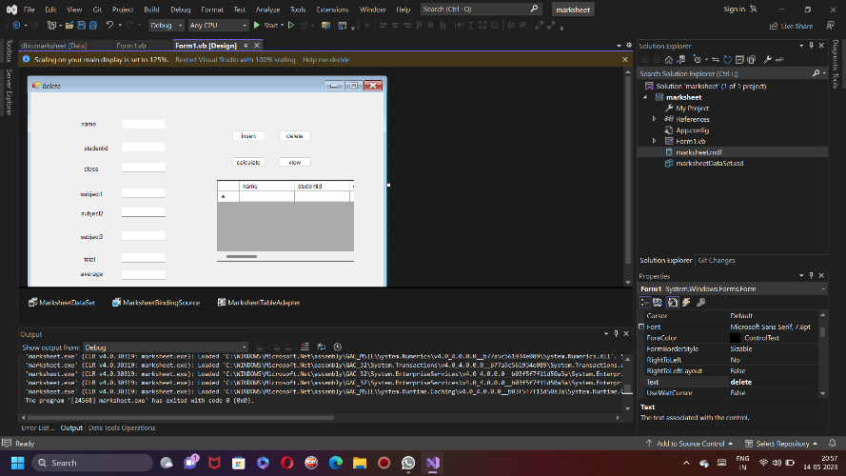

DATABASE:-

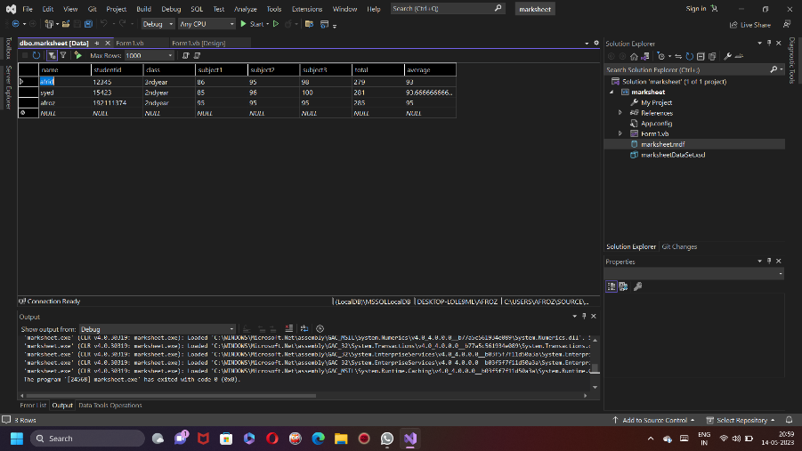

CODE:-

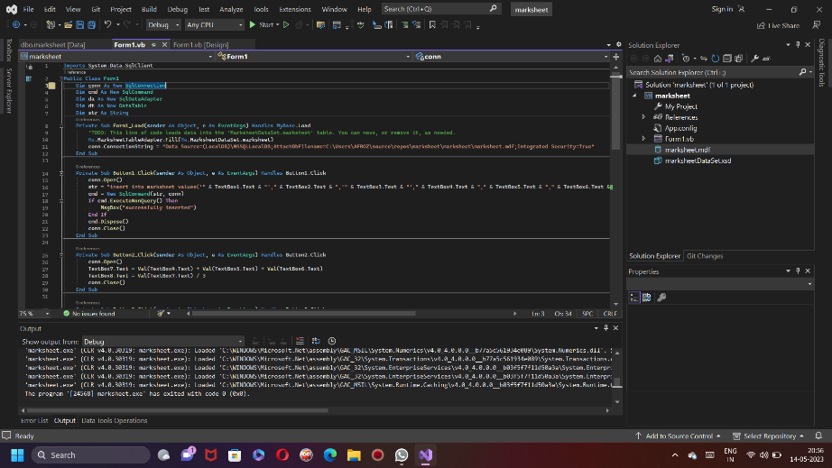

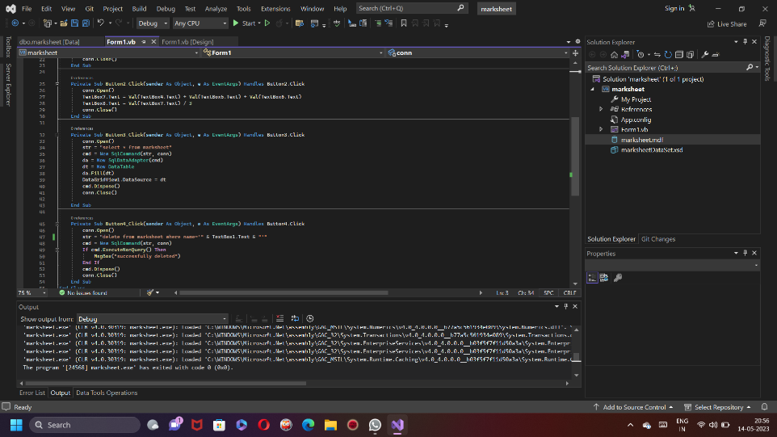

OUTPUT:-

